Task on ASG
(AUTO-SCALING GROUPS)
- Create one VPC in N. Virginia region.
Steps:
Create VPC
Login to AWS ConsoleGo to VPCClick Create VPC
Configuration:
Setting | Value
Name | Asg-vpc
IPv4 CIDR | 50.0.0.0/16
Tenancy | Default
Region | N. Virginia (us-east-1)
Click Create
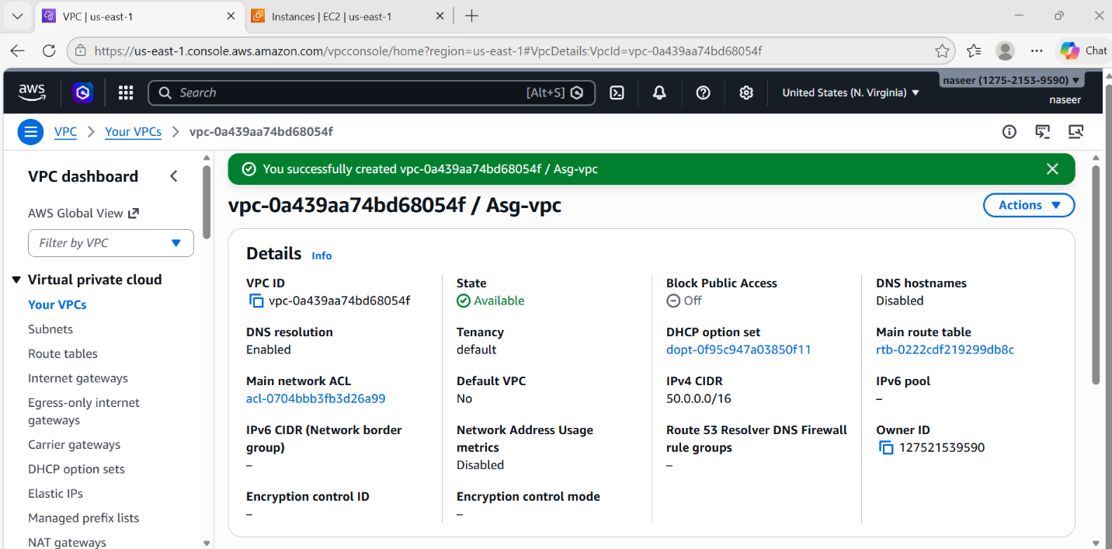

- Create two subnets: one public subnet and one private subnet.
Steps:
Create Subnets
Go to Subnets → Create subnet
Public Subnet
Setting | Value
Name | Asg-pub-Subnet
VPC | Asg-vpc
AZ | us-east-1a
CIDR | 50.0.0.0/24
Enable Auto assign Public IP
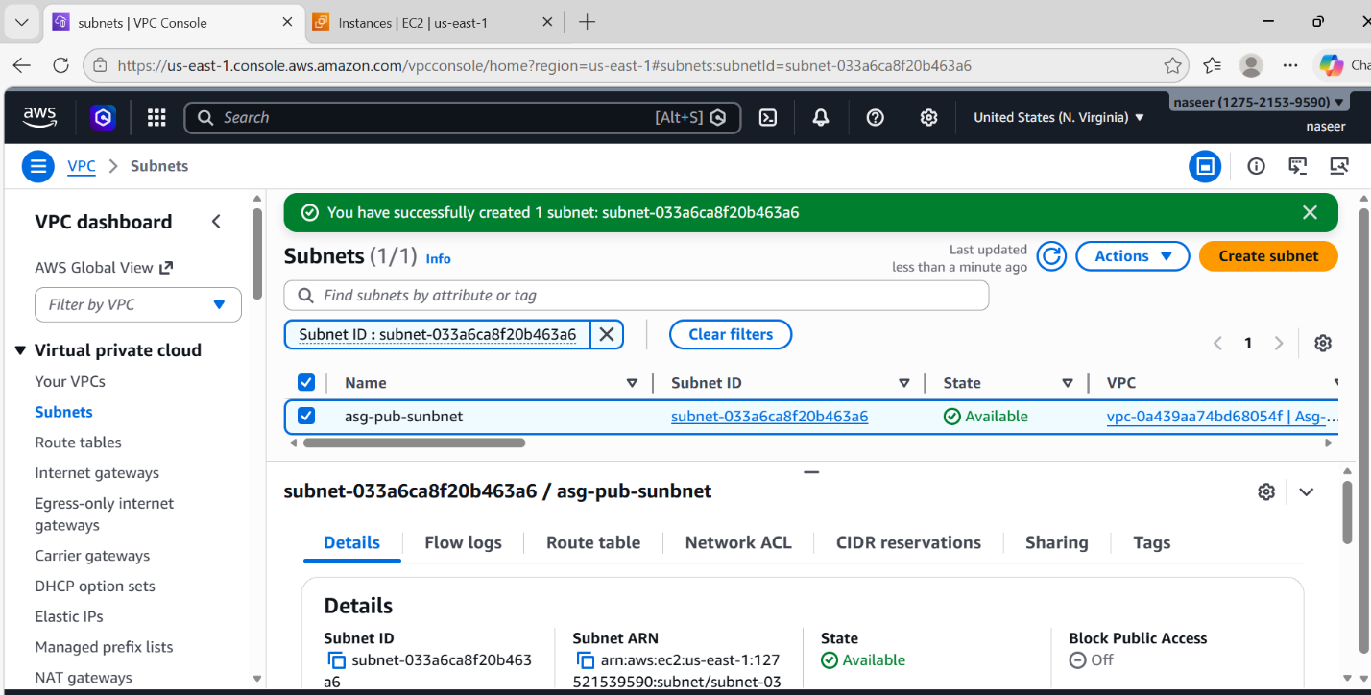
Private Subnet
Setting | Value
Name | Asg-pri-Subnet
VPC | asg-VPC
AZ | us-east-1a
CIDR | 50.0.0.0/26

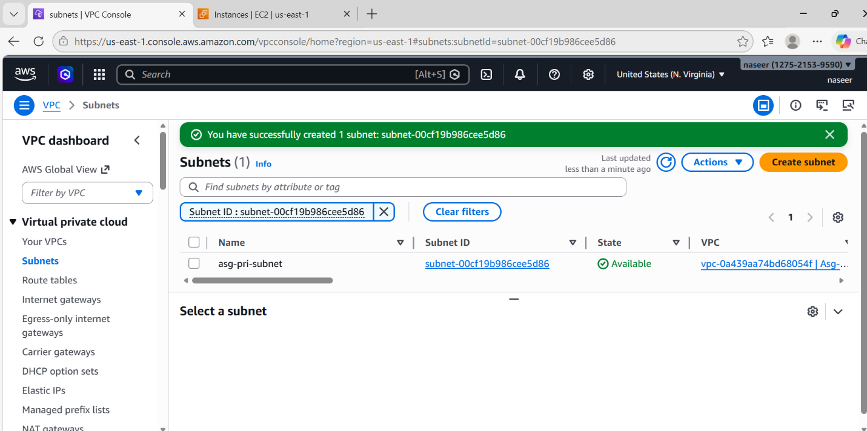
- Attach an IGW to the VPC.
Steps:
Create Internet Gateway
Go to Internet GatewayCreate new
Name asg-igw
After creating:
Attach IGW to VPC
Actions → Attach → Select asg-VPC

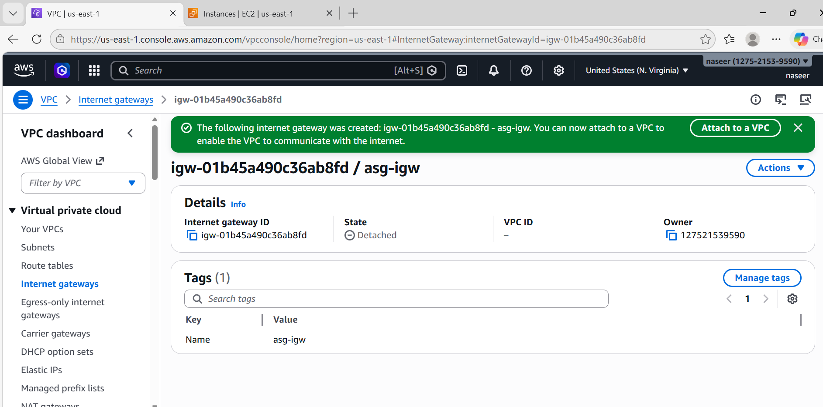

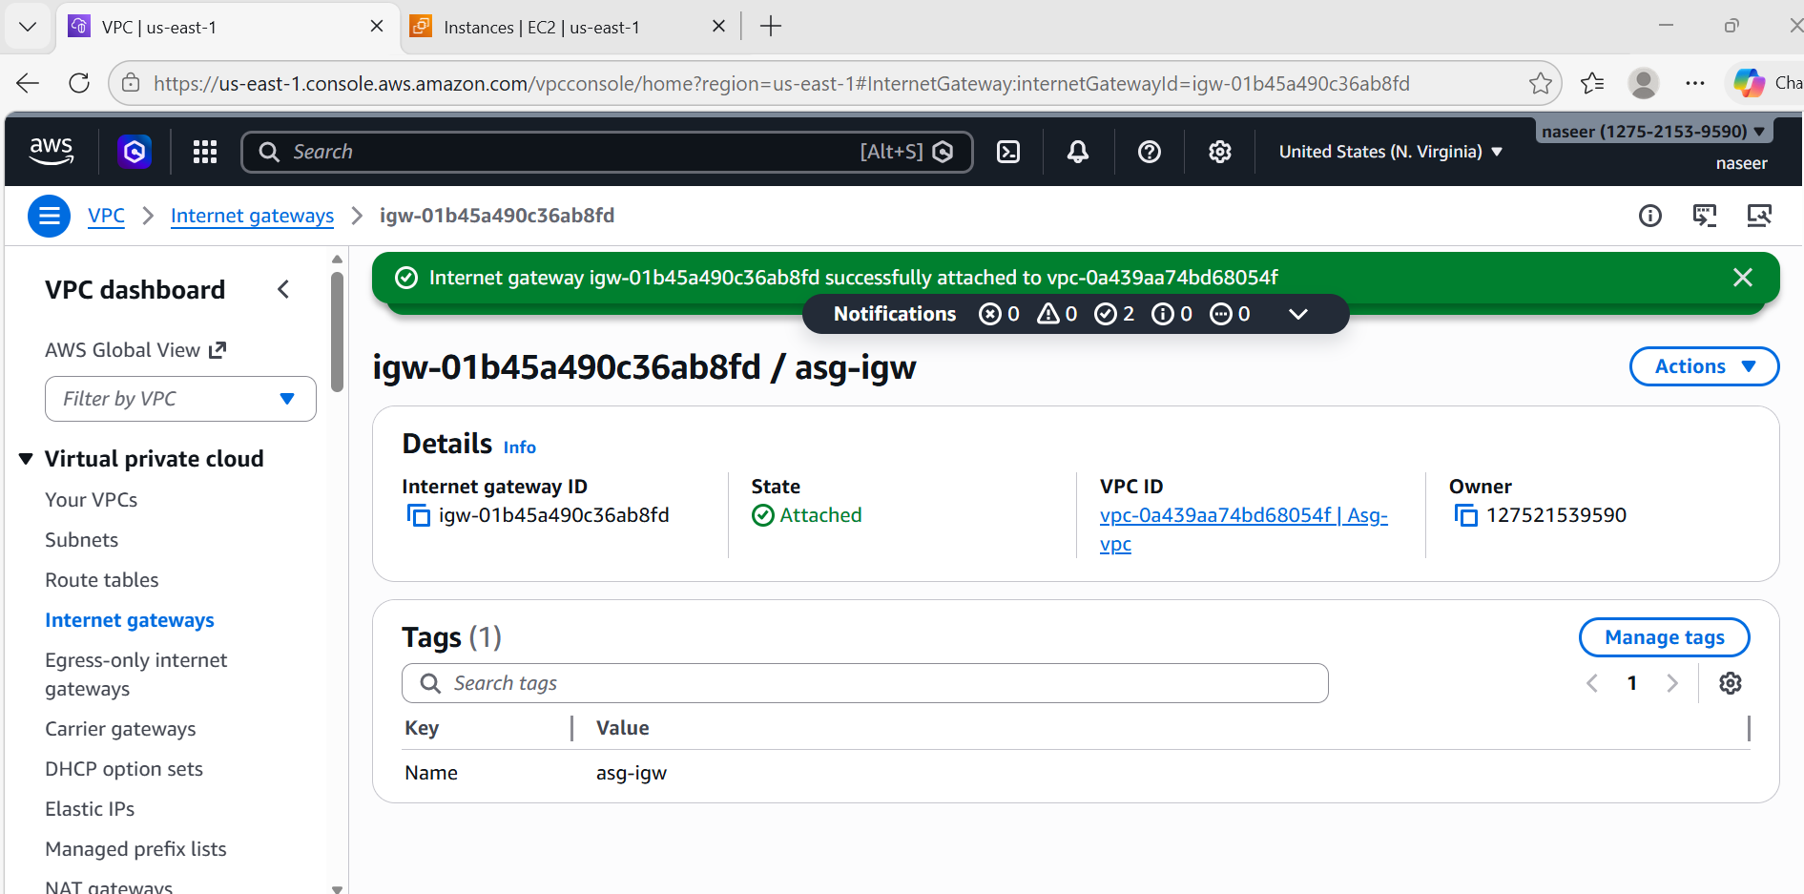
- Create one public route table (RT) and one private route table.
Steps:
Create Route Tables
Public Route Table
Go to Route Tables → Create
Name asg-pub-rt
VPC asg-VPC
Edit Routes:
Add:
Destination : 0.0.0.0/0
Target : Internet Gateway (asg-IGW)
Associate:
Subnet → Public-Subnet

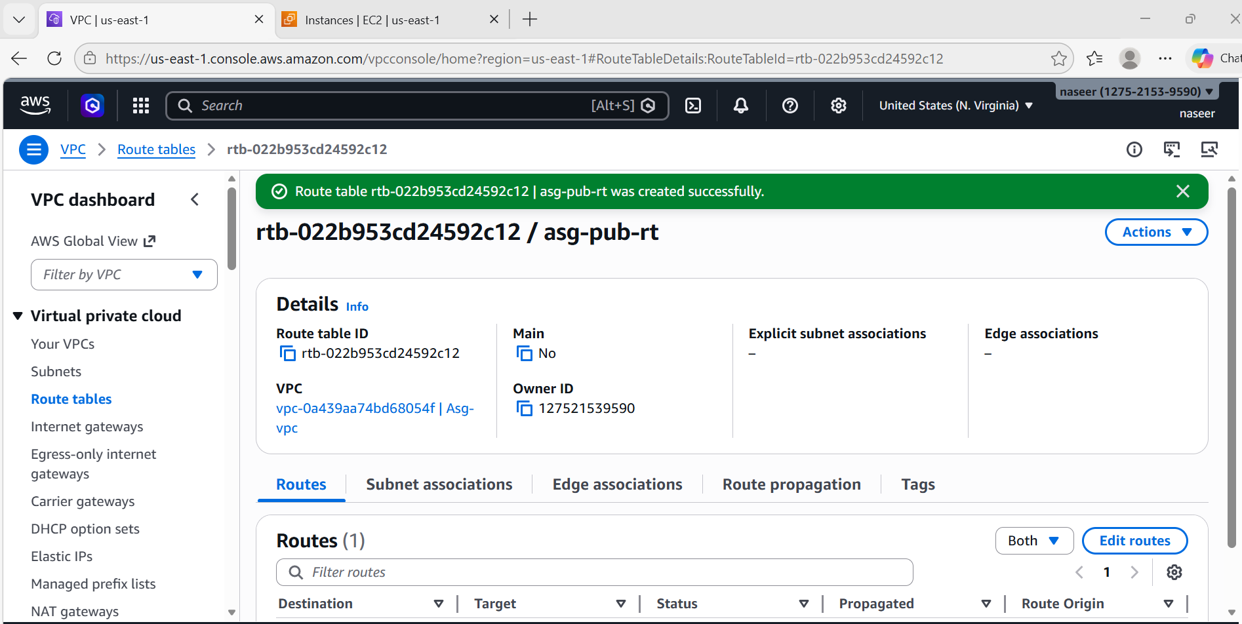

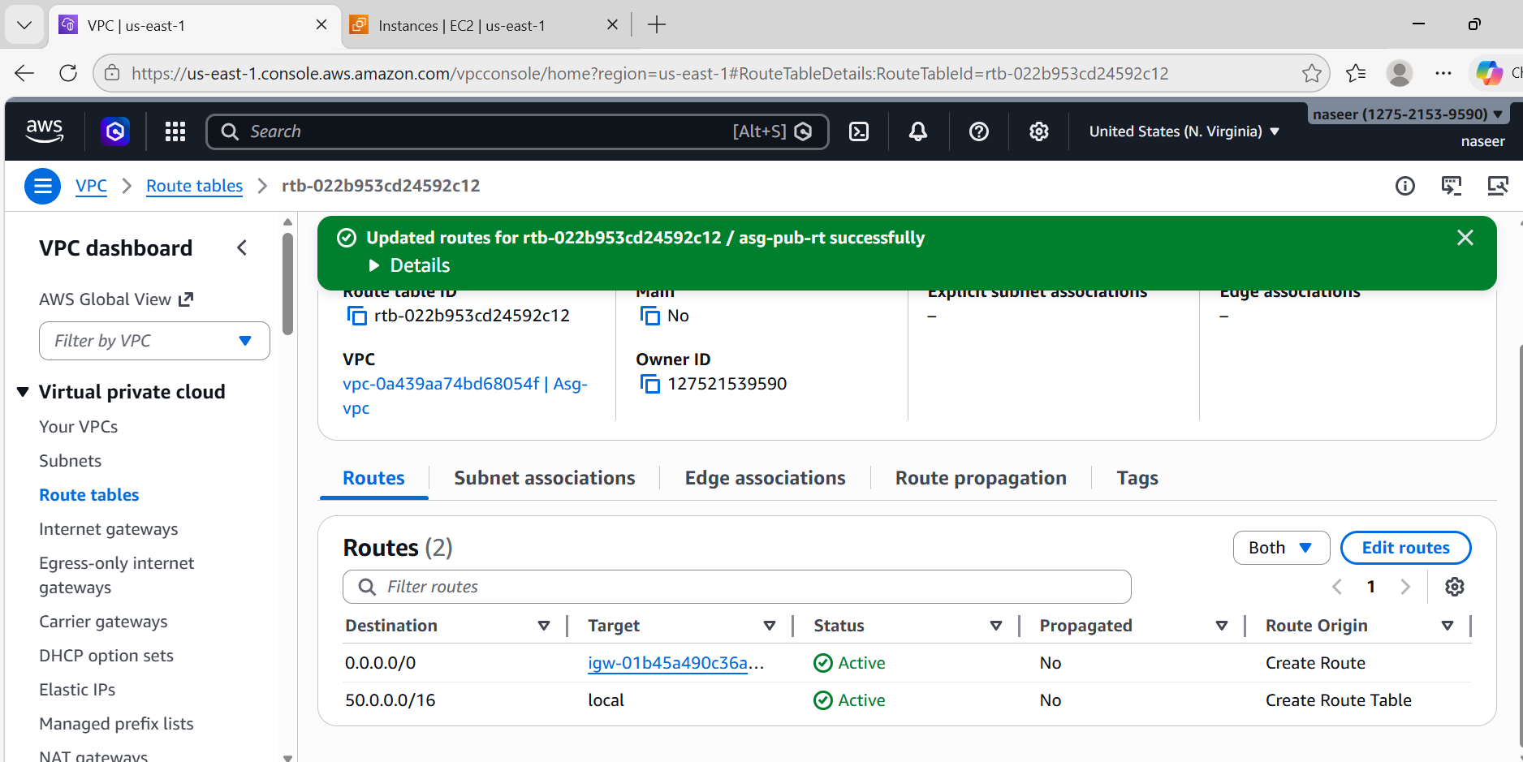

Private Route Table
Create another:
Name asg-pri-rt
Associate:
Subnet → Private-Subnet

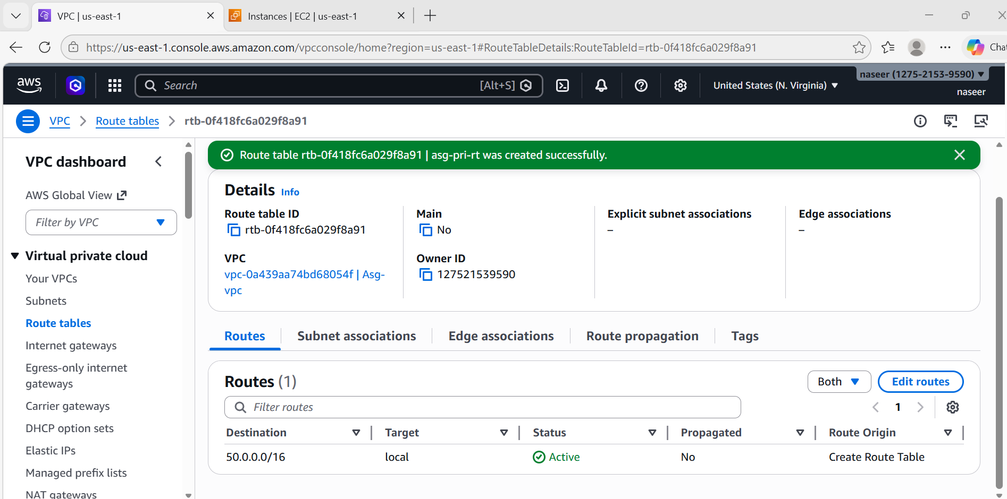
- Deploy a NAT gateway in the public subnet and attach the NAT gateway to the private subnet.
Steps:
Create NAT Gateway
Go to NAT Gateway
Create NAT:
Setting | Value
Name | Asg-natgw
Subnet | Public-Subnet
Elastic IP | Allocate new
Click Create
Attach NAT to Private Route Table
Go to Private-RT
Edit Routes
Add:
Destination : 0.0.0.0/0
Target : NAT Gateway
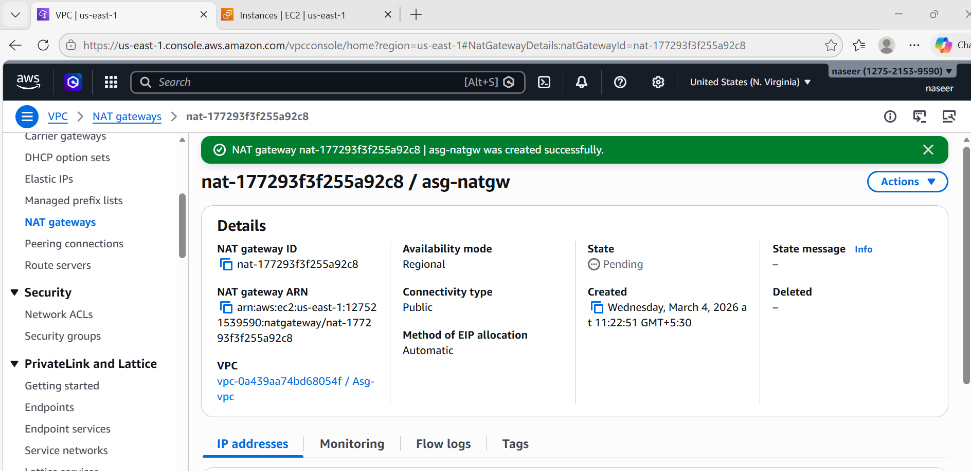
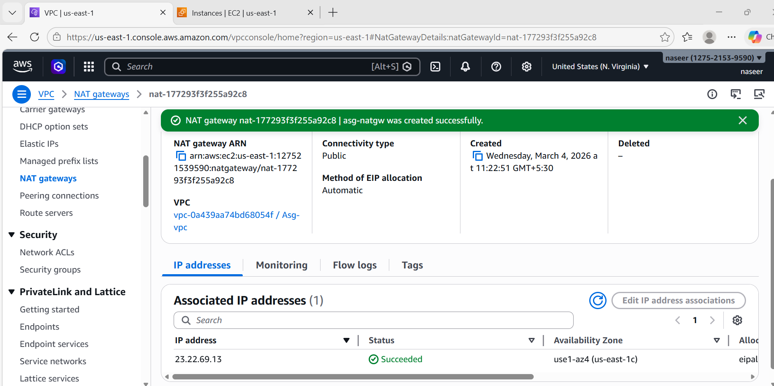
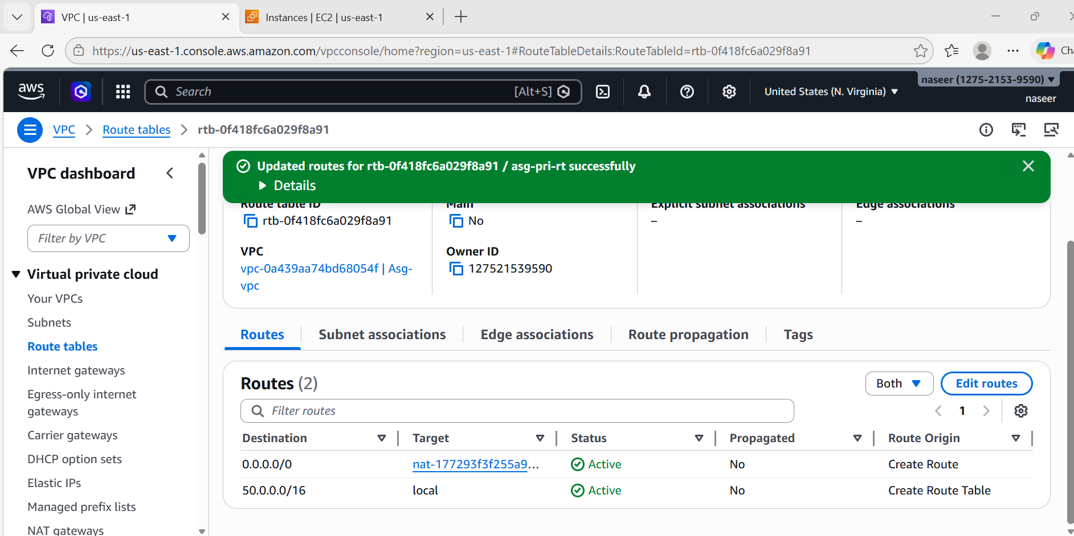
- Create two instances, one in the public subnet and one in the private subnet.
Steps:
Launch EC2 Instances
Go to EC2 → Launch Instance
Public EC2
Configuration:
Setting | Value
Name | Asg-pub-ec2
AMI | Amazon Linux 2
Type | t3.micro
Subnet | Public-Subnet
Auto Public IP | Enable
Security Group:
Allow:
HTTP 80
SSH 22

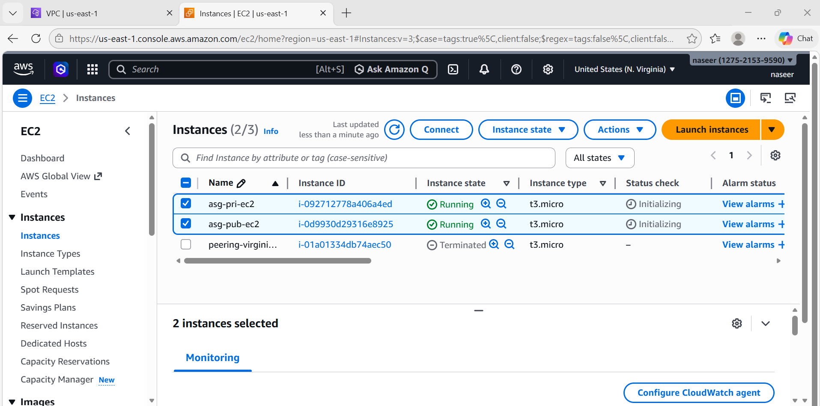
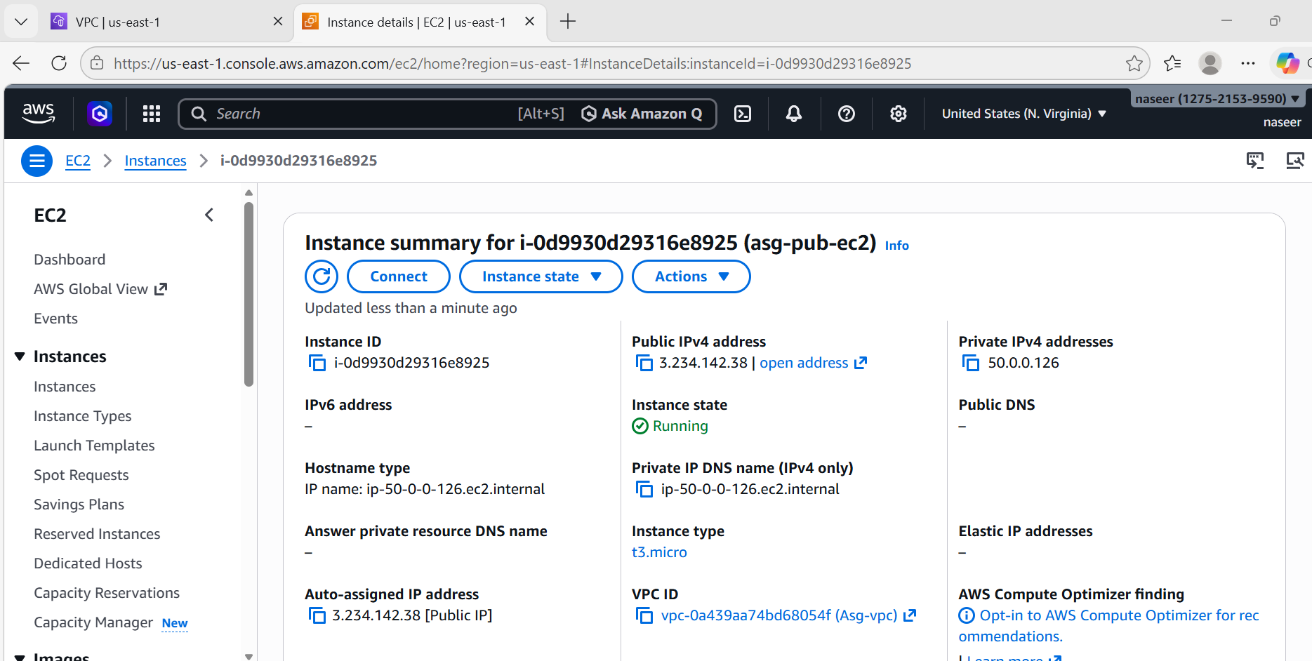
Private EC2
Launch another:
Setting | Value
Name | Asg-pri-ec2
AMI | Amazon Linux 2
Subnet | Private-Subnet
Public IP | Disable
Security group:
Allow:
HTTP 80
SSH from Public Instance Security Group

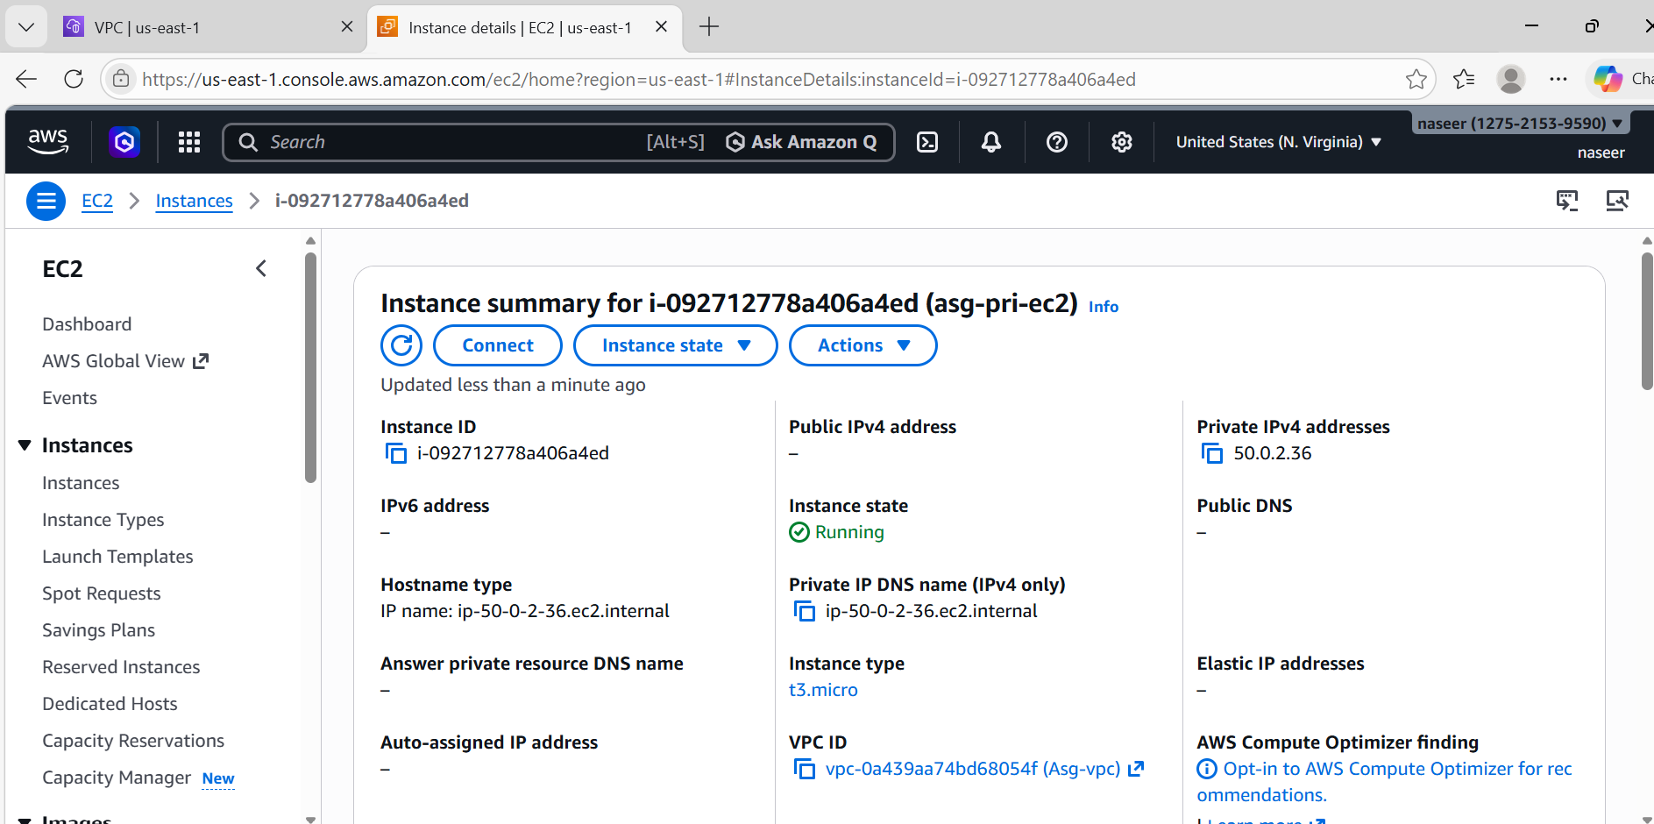
- Deploy Apache server on both EC2 instances with a sample index.html file.
Steps:
Install Apache on Both EC2
SSH into Public Instance
Run:
sudo yum update -y
sudo yum install httpd -y
sudo systemctl start httpd
sudo systemctl enable httpd

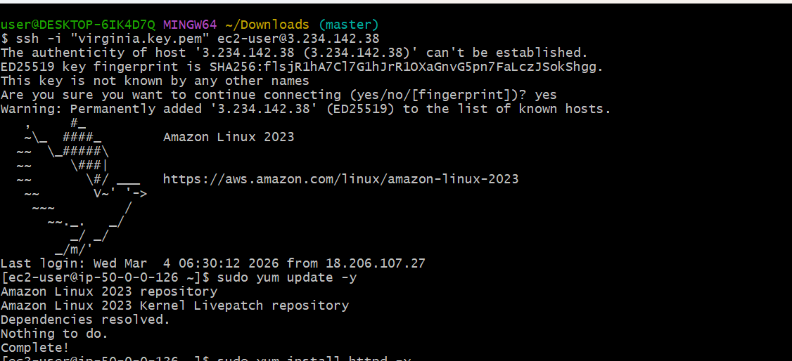
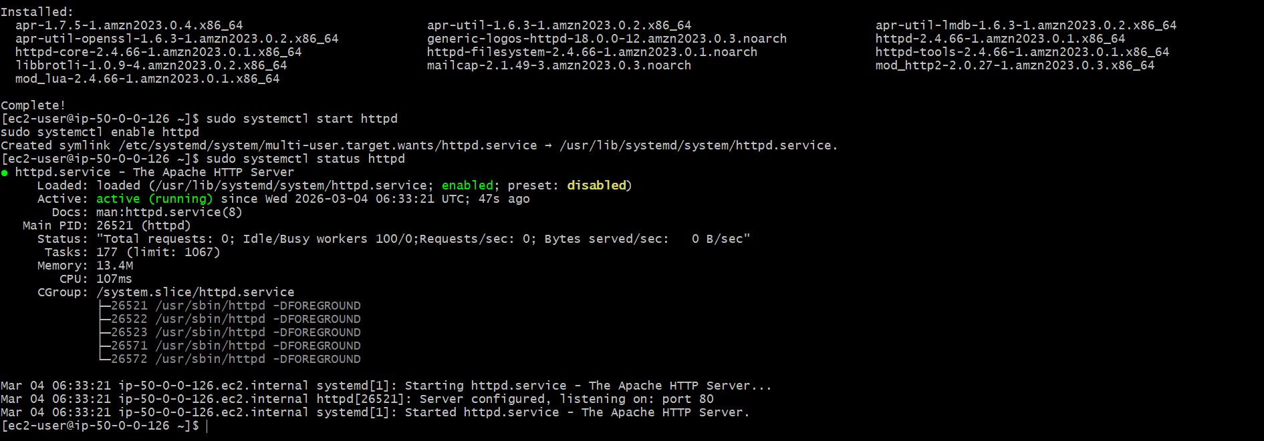
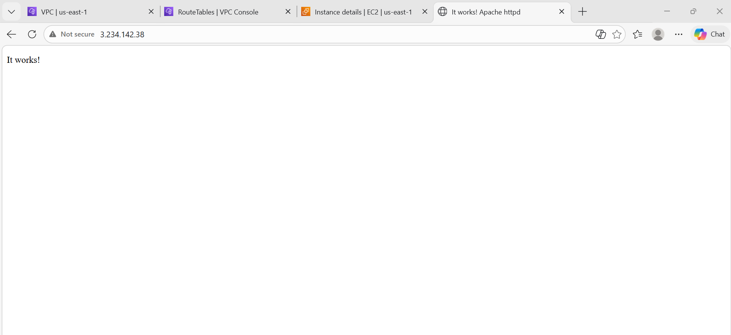
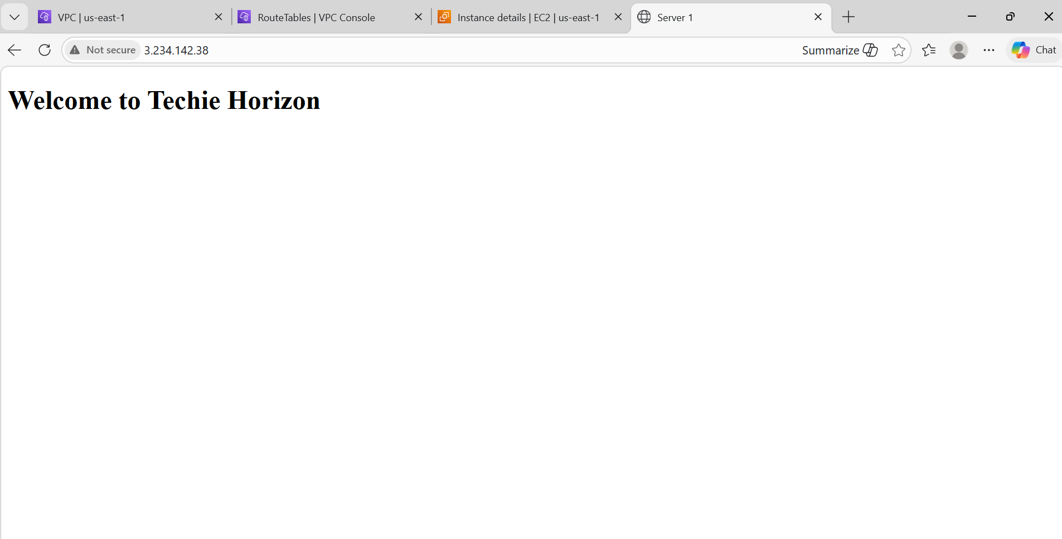
Now SSH into Private instance via Public instance (Bastion)
ssh ec2-user@private-ip
Install Apache:
sudo yum update -y
sudo yum install httpd -y
sudo systemctl start httpd
sudo systemctl enable httpd

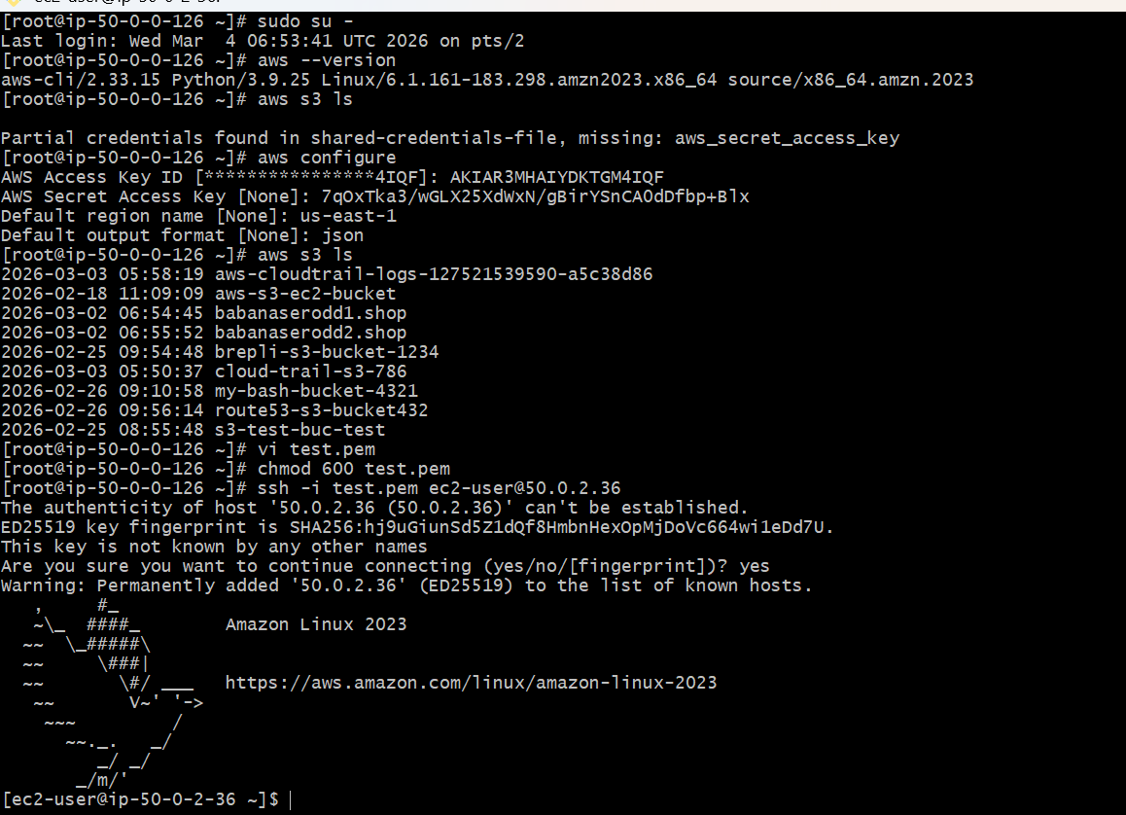

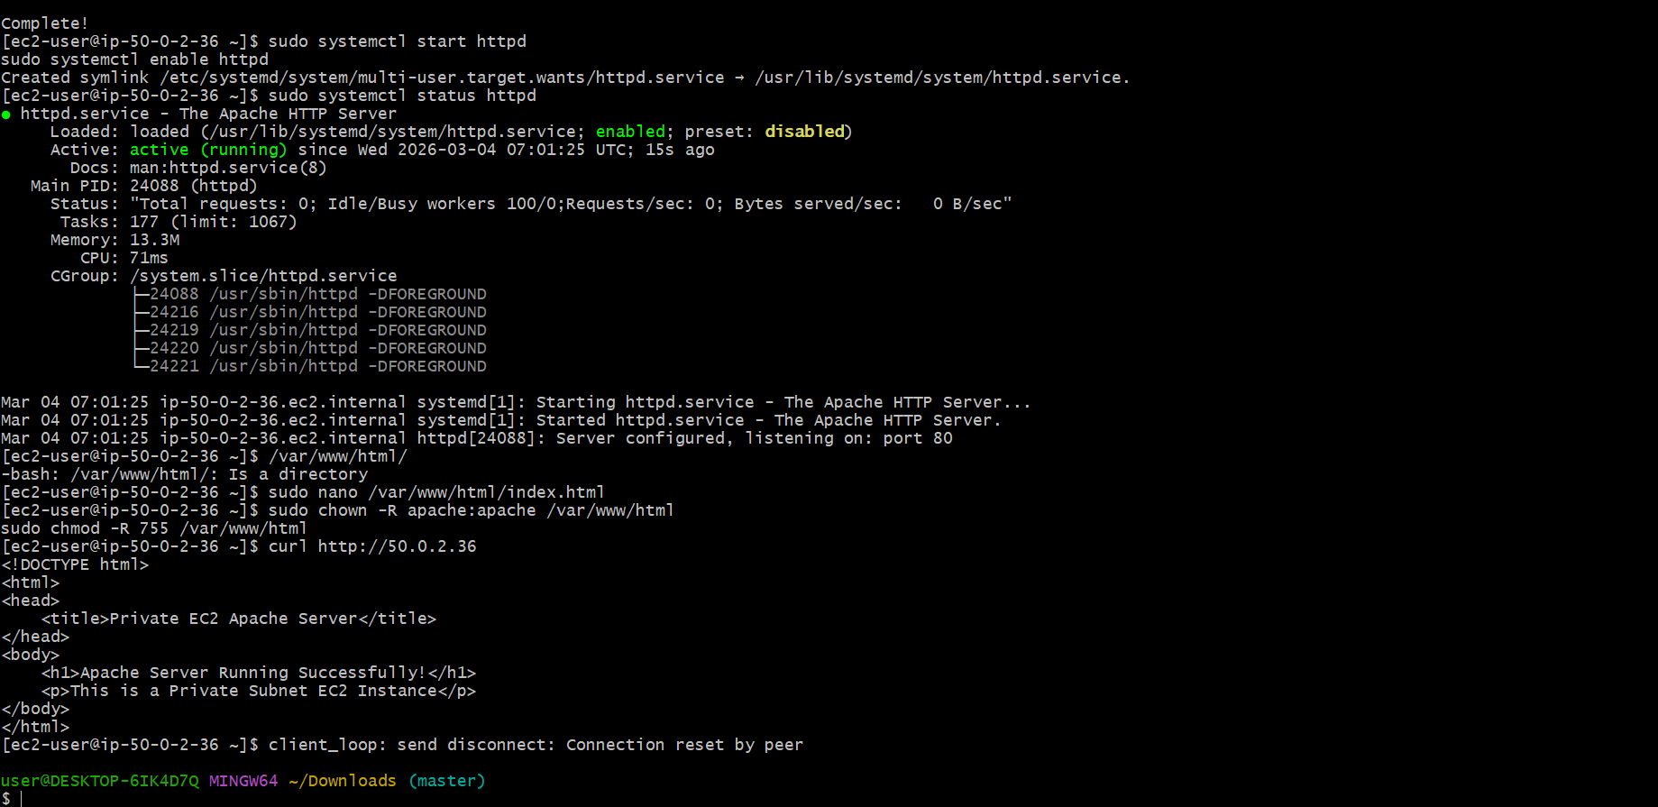
- Create one application load balancer and attach it to both EC2 instances.
Steps:
Create Application Load Balancer
Go to EC2 → Load BalancerCreate Application Load Balancer
Configuration:
Setting | Value
Name | Asg-alb
Type | Internet Facing
VPC | Asg-vpc
Subnets | Public-Subnet
Listener:
HTTP : 80
Create Target Group
Setting | Value
Name | Asg-target-group
Target Type | Instance
Protocol | HTTP
Port | 80
Register targets:
Public-Server
Private-Server

Now access:
ALB DNS Name:
asg-alb-1139366941.us.east-1.elb.amazonaws.com
Traffic will load balance between servers.

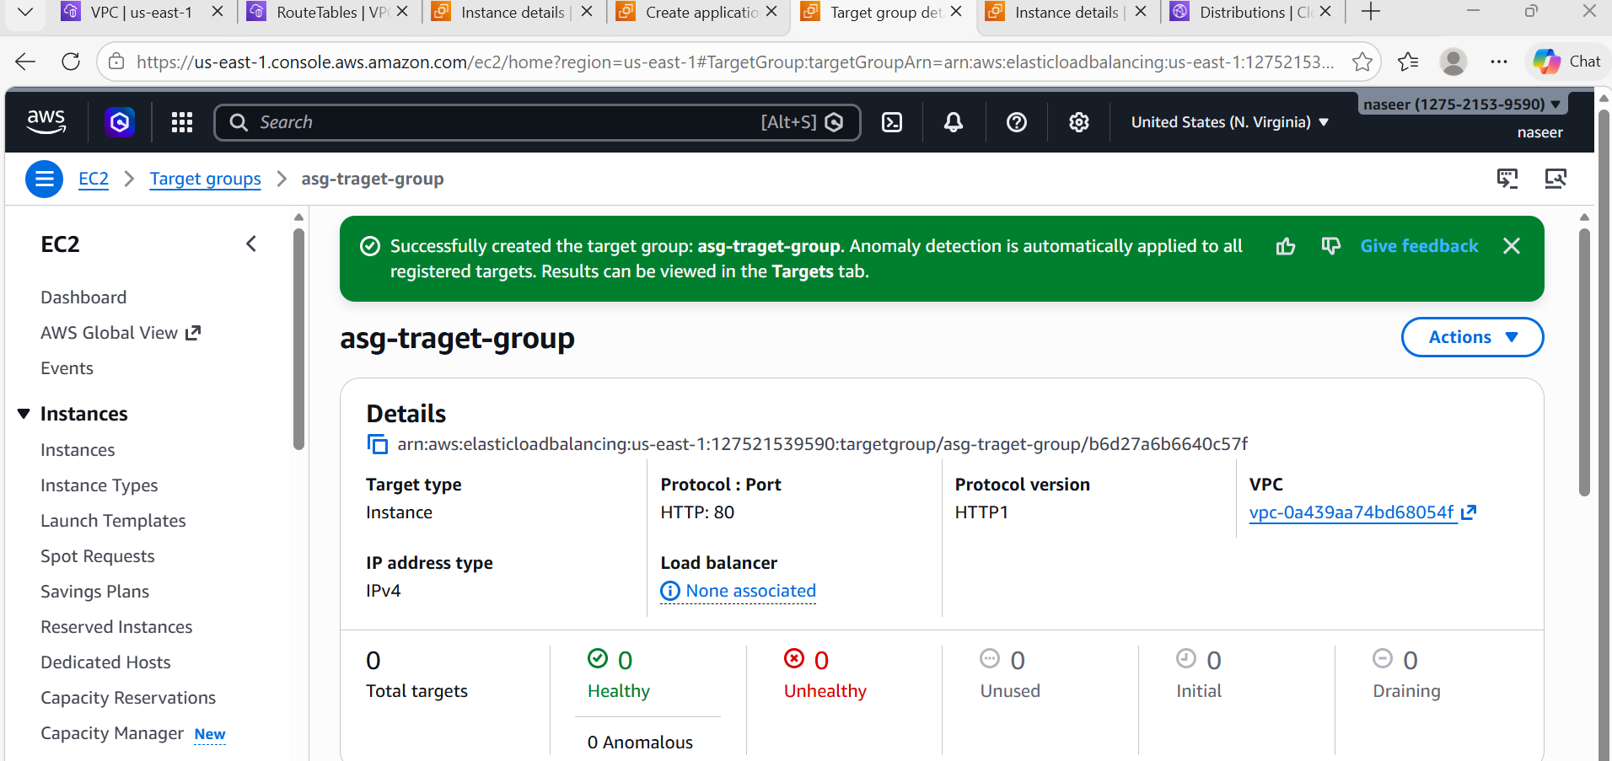
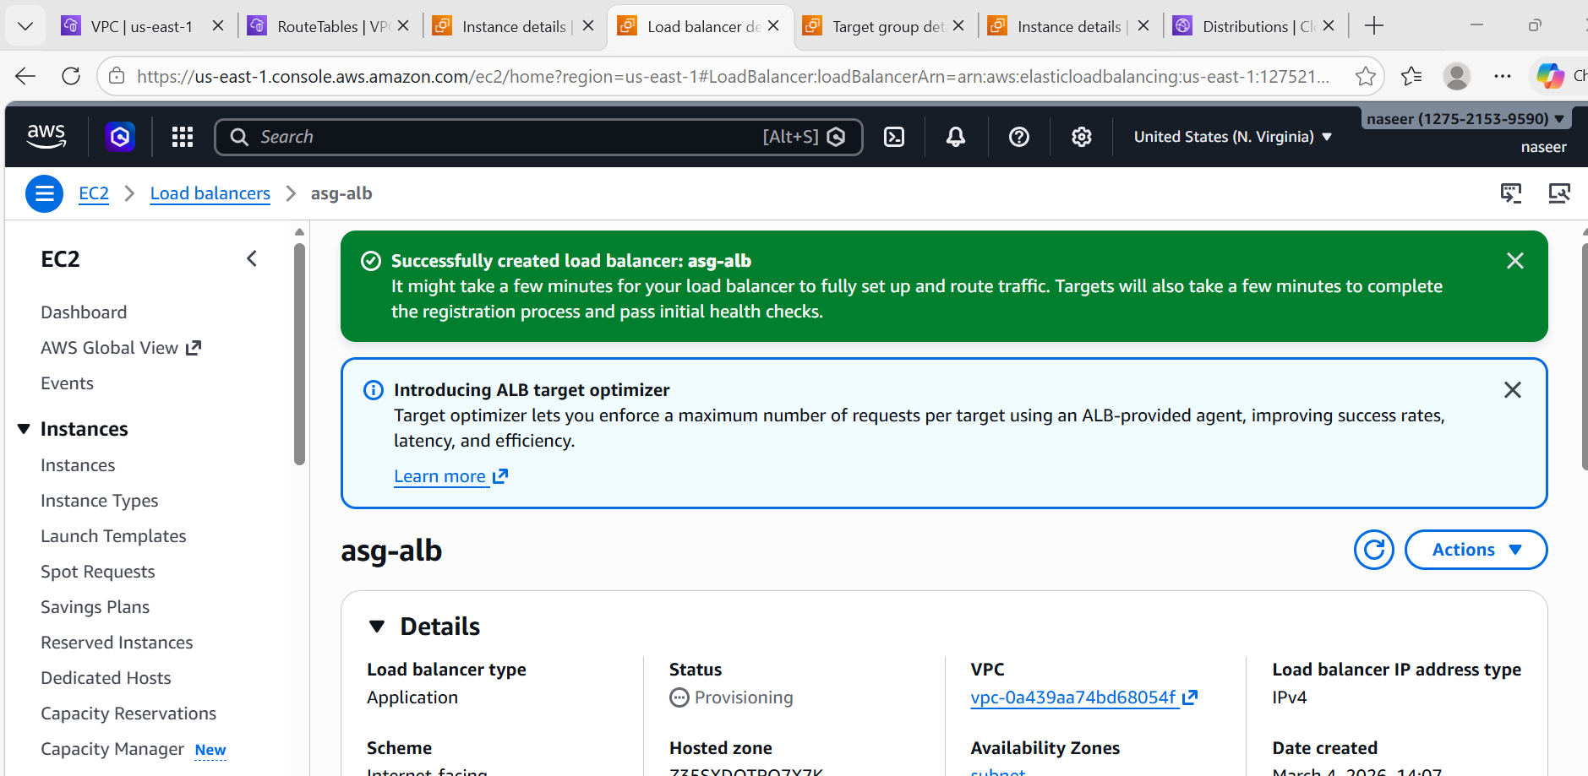
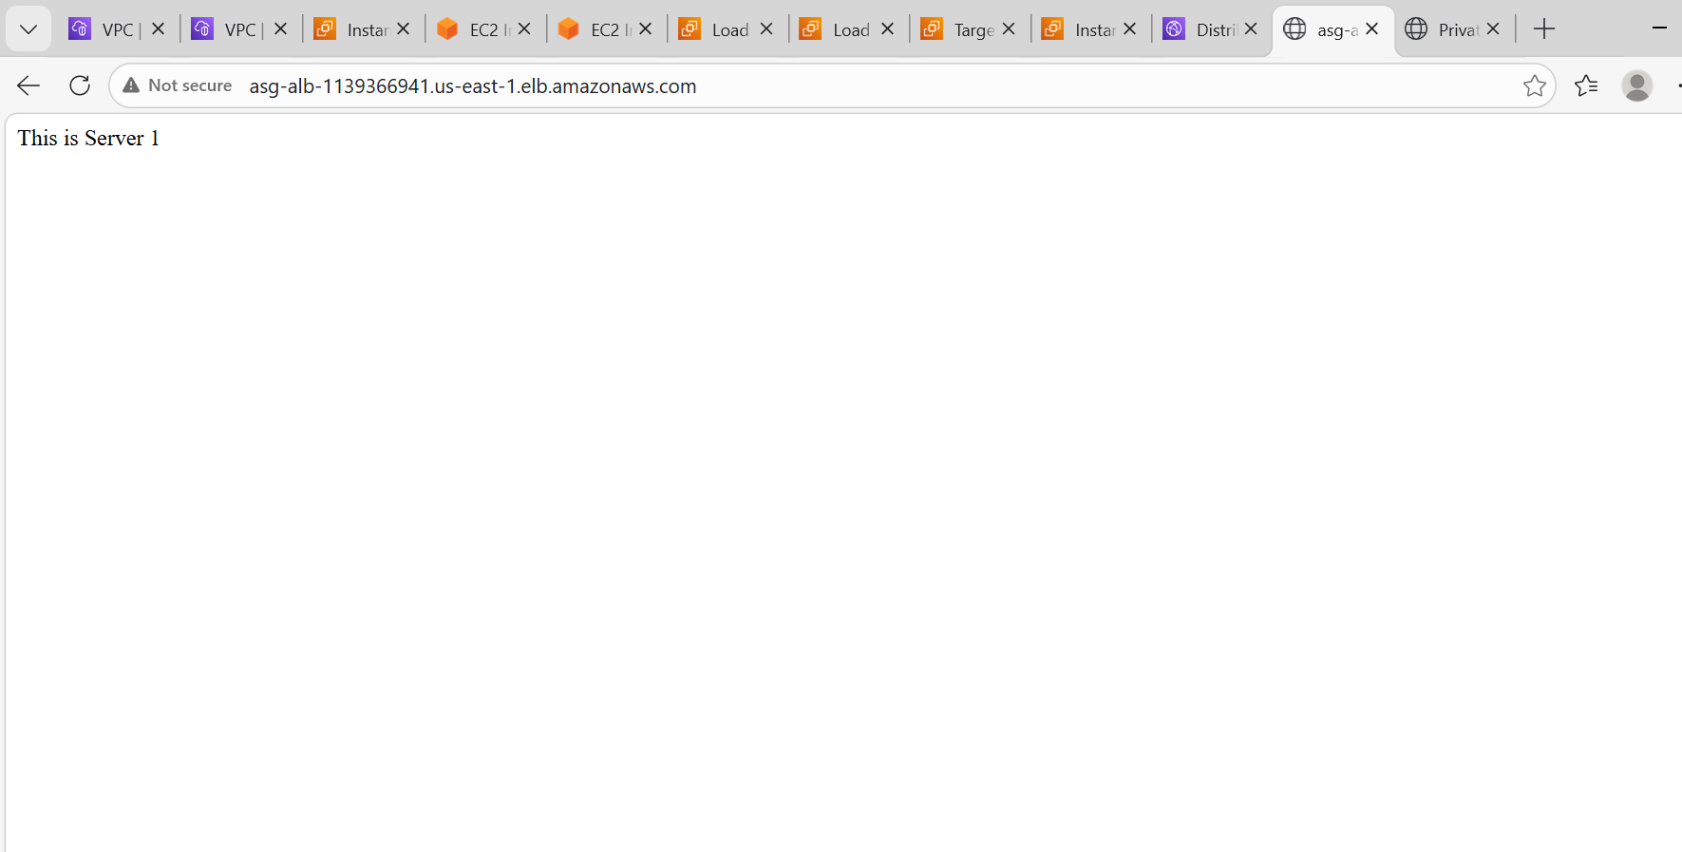
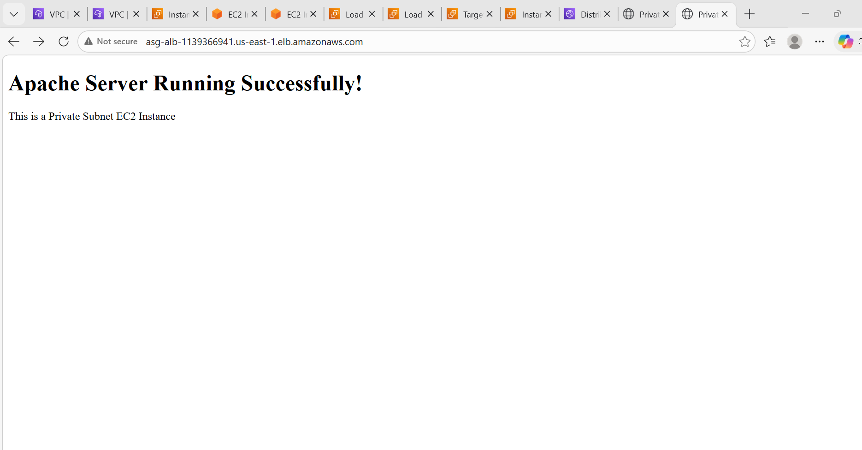
- Store application load balancer logs in S3.
Steps:
Store ALB Logs in S3
Go to S3Create bucket: applicationlb-bucket
Go to Load Balancer → Attributes
Enable:
Access logs → Enabled
Bucket → applicationlb-bucket
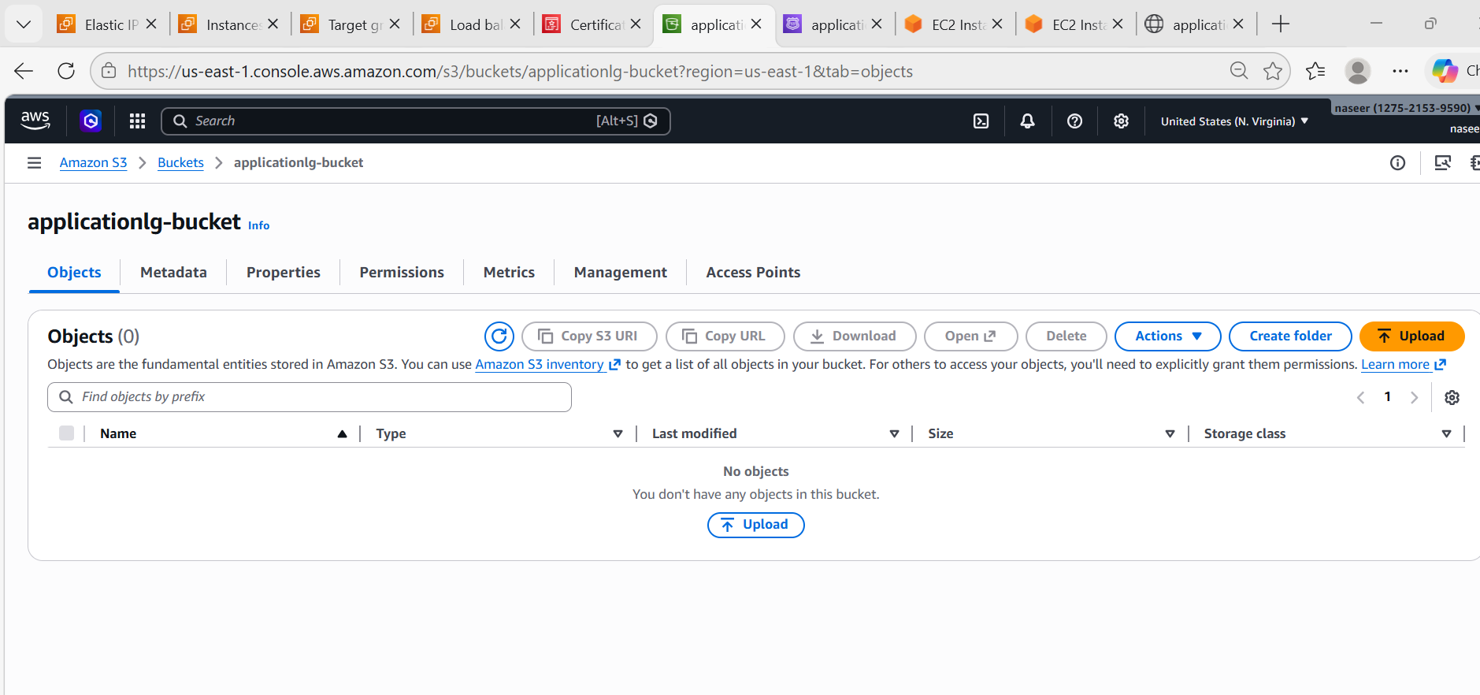
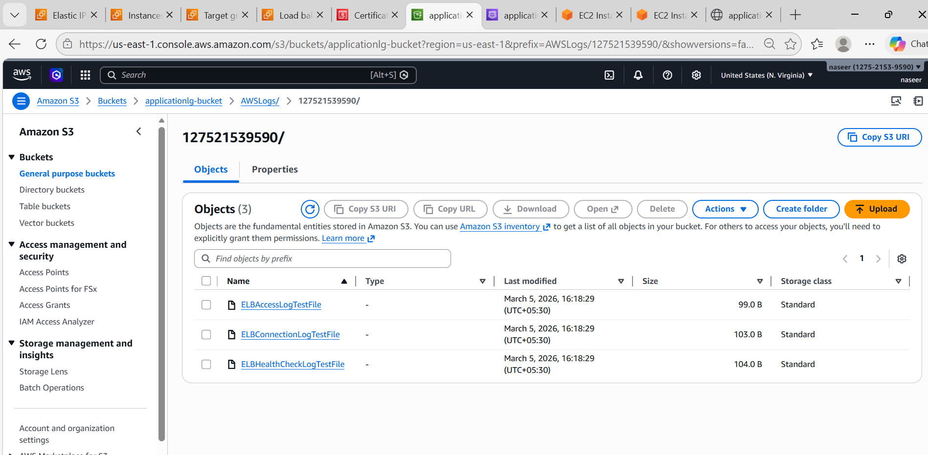
- Store the VPC flow logs in a CloudWatch log group.
Steps: Enable VPC Flow Logs
Go to VPC → Flow Logs
Create:
Setting | Value
Resource | asg-VPC
Destination | CloudWatch
Log Group | vpc-flow-logs

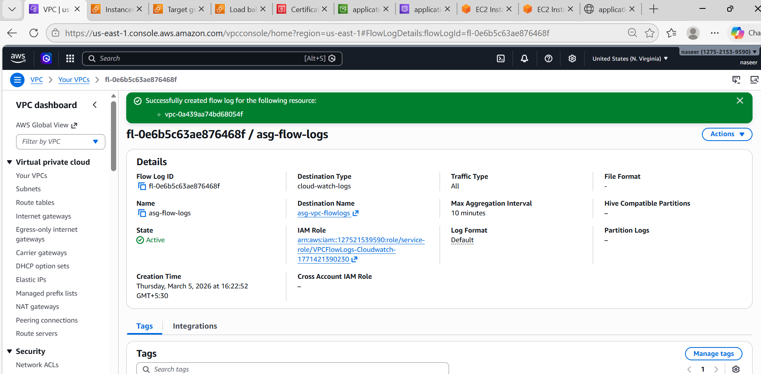
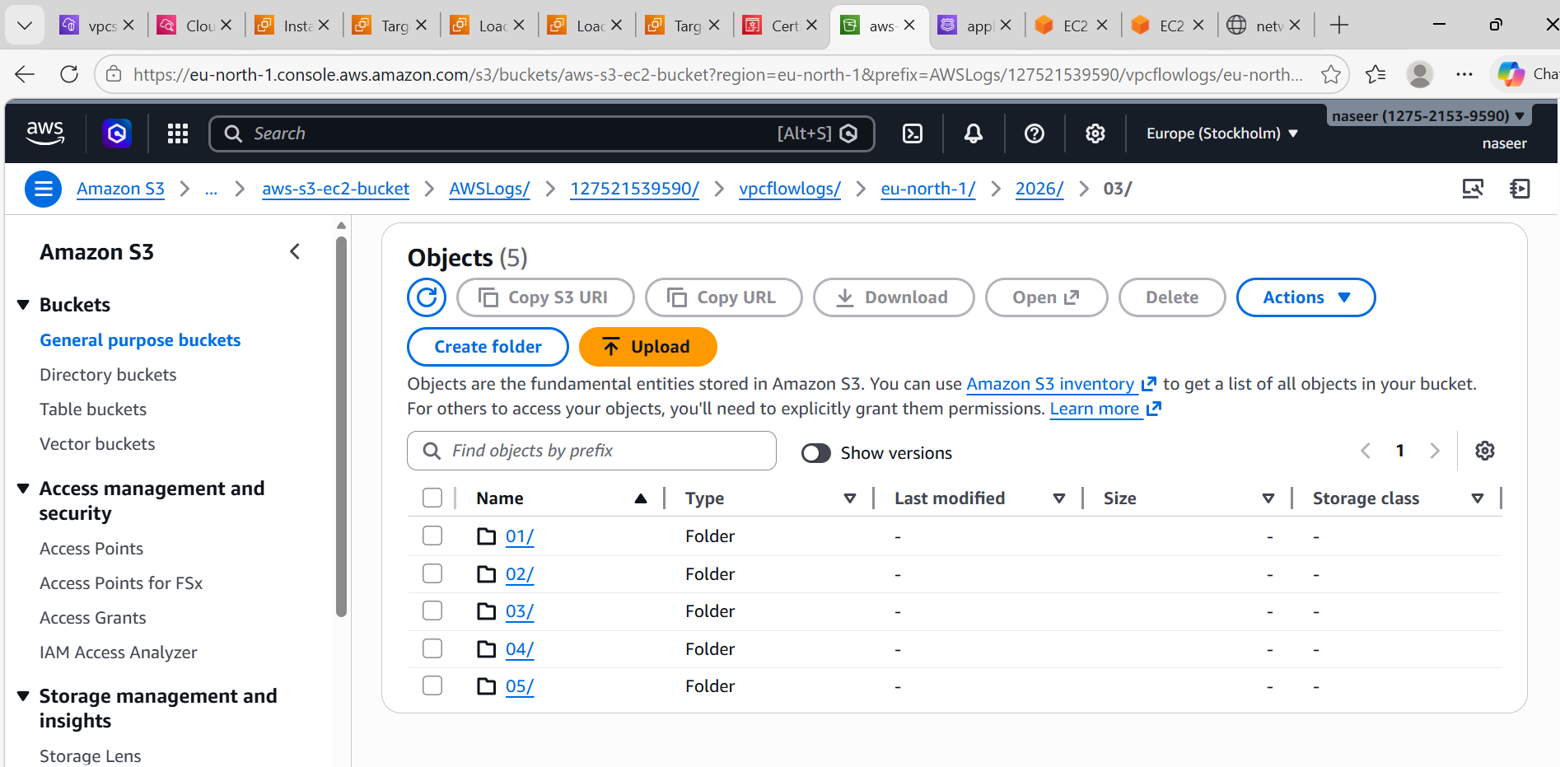
- Create monitoring dashboards to monitor CPU utilization and to monitor the Apache service.
Steps:
Create CloudWatch Dashboard
Go to CloudWatch → Dashboard
Create dashboard:
Cpu-apache-Monitoring
Add widget:
CPU Utilization
Metric → EC2 → Per Instance → CPUUtilization
Add both instances.
Apache Monitoring
Install CloudWatch agent.
SSH into instance:
sudo yum install amazon-cloudwatch-agent
Configure logs for Apache.

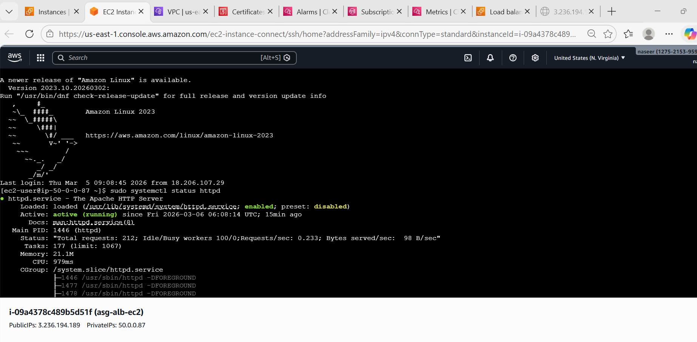
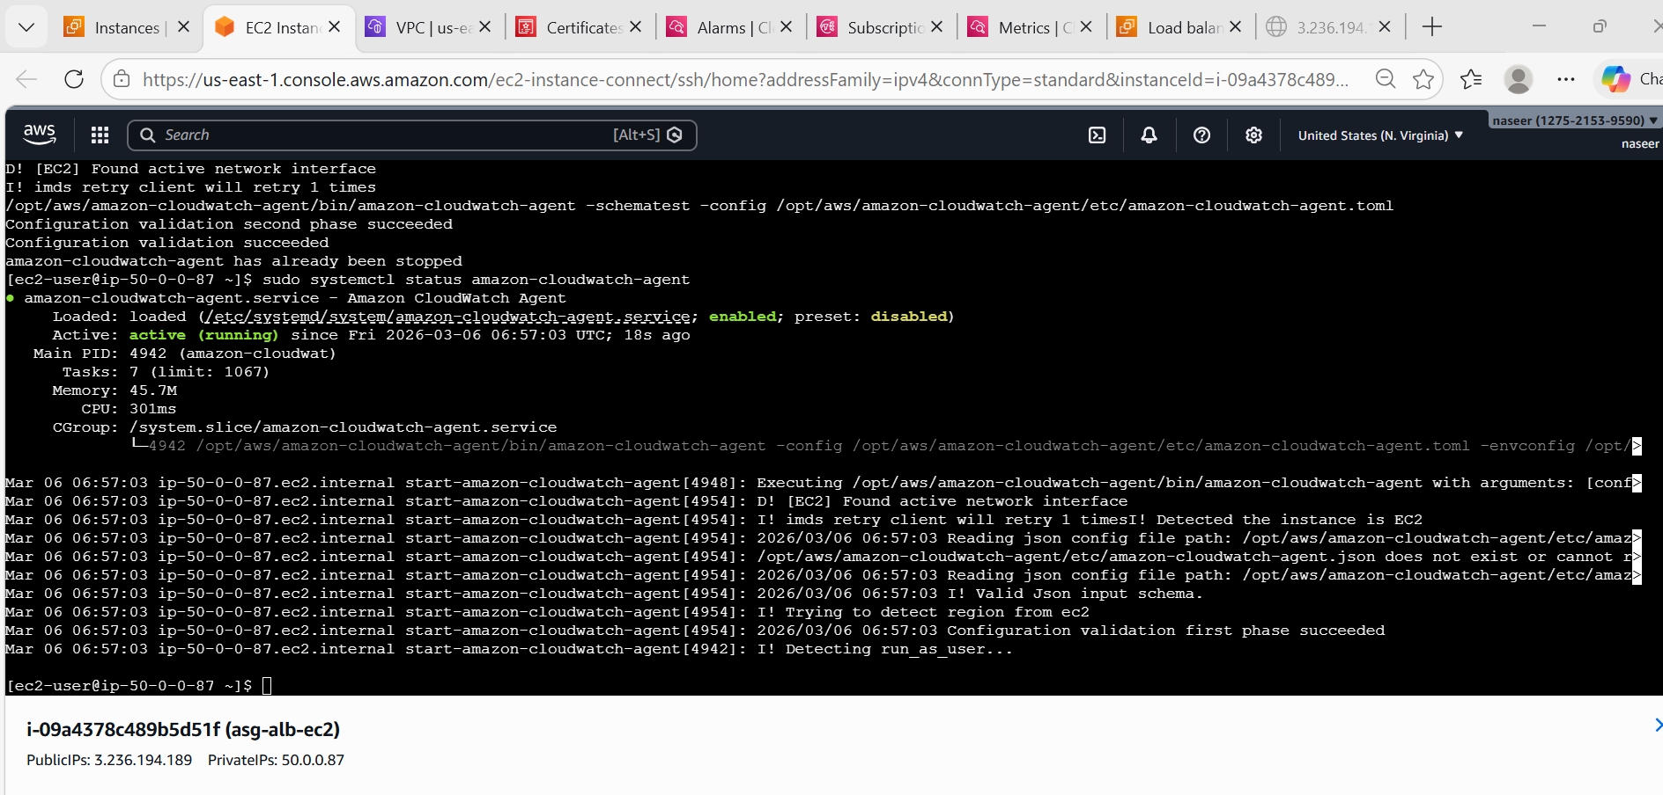
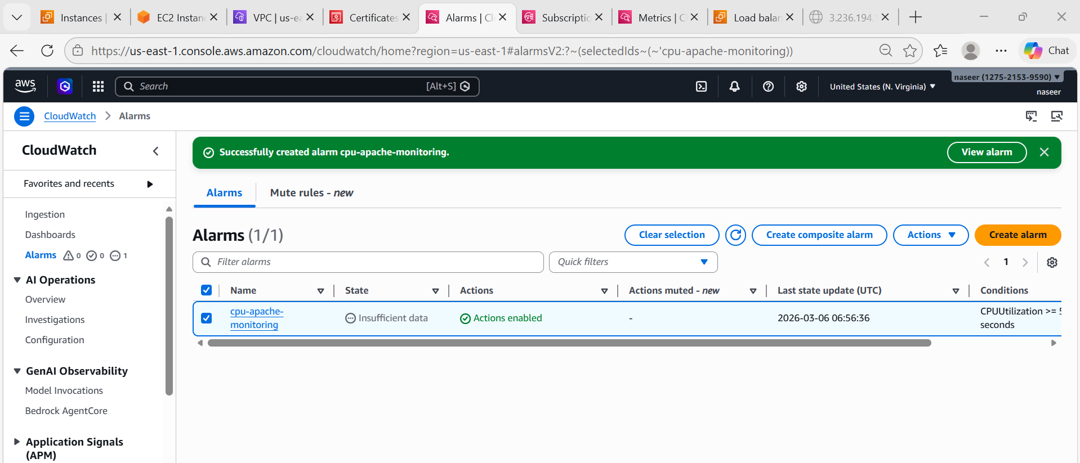
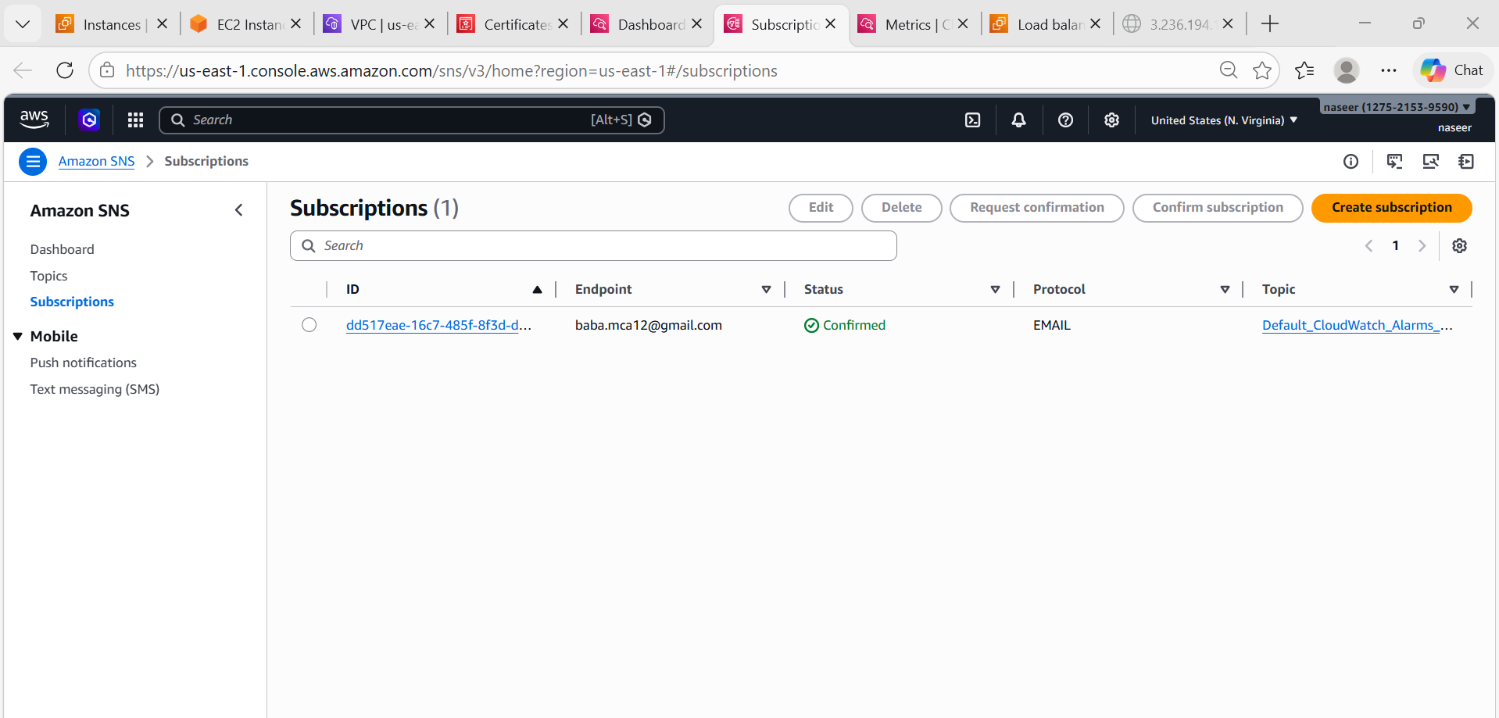
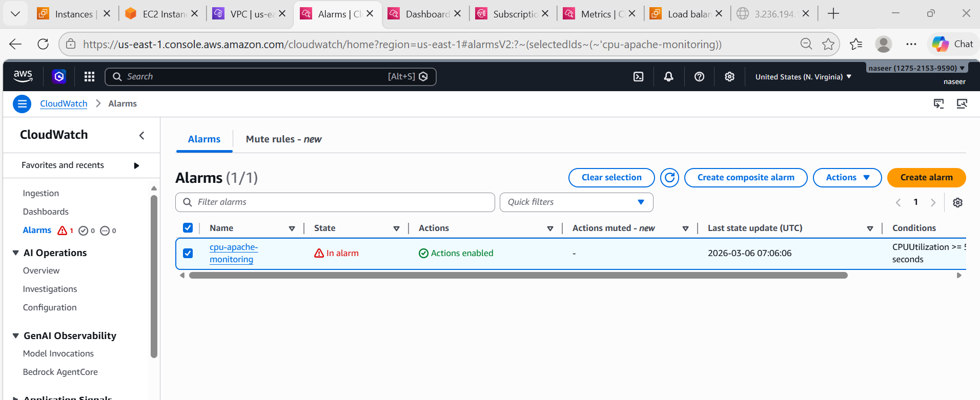
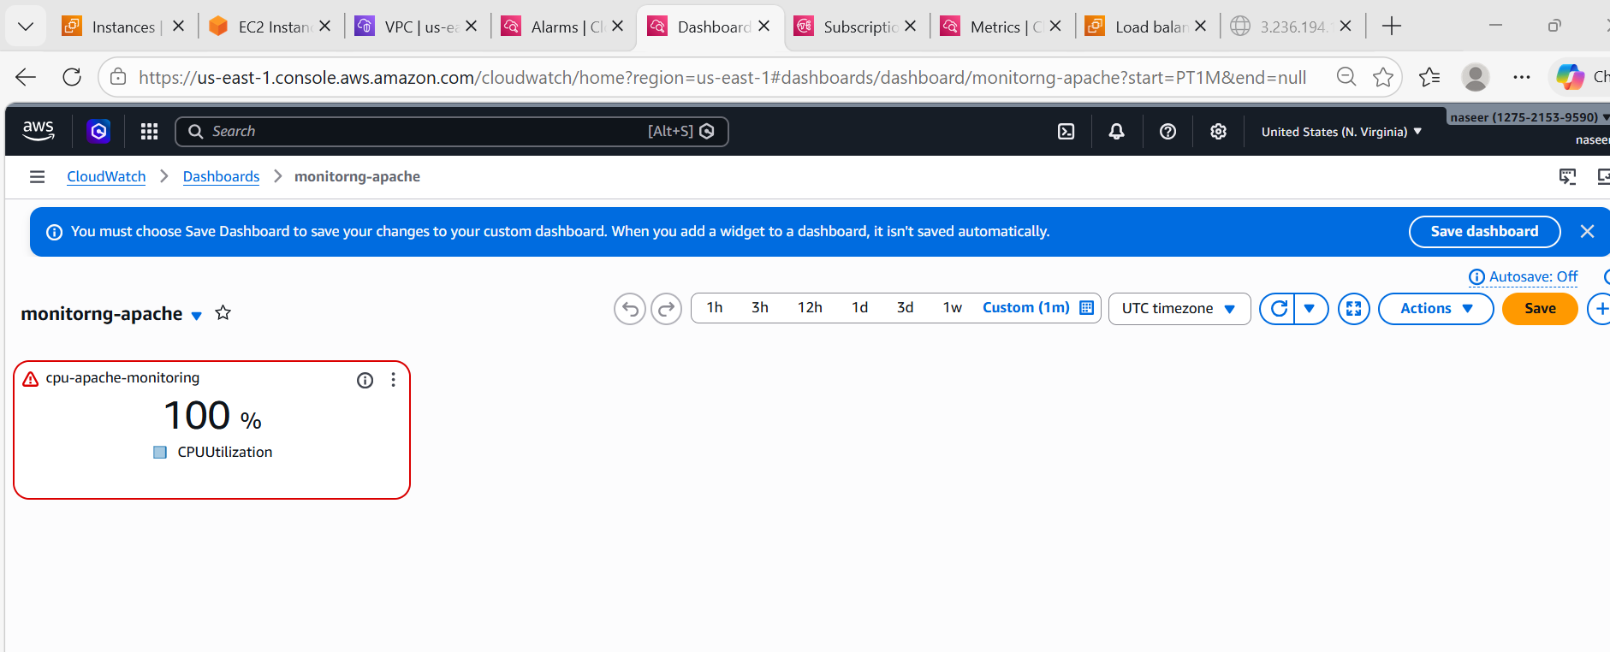
- If CPU utilization is more than 70%, then it should trigger auto scaling and launch new instance.
Step 12 — Auto Scaling Based on CPU
Go to Auto Scaling → Create Auto Scaling Group
First create Launch Template
Configuration:
Setting | Value
AMI | Amazon Linux
Instance Type | t3.micro
Security group | Web-SG
Create Auto Scaling Group
Setting | Value
Min | 1
Desired | 2
Max | 4
Attach to:
Apache Target Group

Create Scaling Policy
Policy Type:
Target Tracking
Metric:
Average CPU Utilization
Threshold:
70%
Now:
If CPU > 70%
New EC2 instance will launch automatically
